Ladies Ancient Order of Hibernians, Inc.
Membership Application

Name: Click or tap here to enter text.

Address 1: Click or tap here to enter text.
Address 2: Click or tap here to enter text.
City: Click or tap here to enter text.
County: Click or tap here to enter text.
State: Click or tap here to enter text.
Zip Code: Click or tap here to enter text.

Birth Date(m/d/yr) Click or tap here to enter text.
Phone Number: Click or tap here to enter text.
Email Address: Click or tap here to enter text. Occupation: Click or tap here to enter text.
Referring individual or organization name:
Are you Catholic? ☐ Yes ☐No
Do you belong to any organization(s) that the Catholic Church is opposed? ☐ Yes* ☐ No
*Organization(s): Click or tap here to enter text.
Are you Irish by birth, descent, adoption or marriage? ☐Yes ☐No
Were you ever a Member of the Ladies Ancient Order of Hibernians? ☐ Yes ☐ No
Have you served/are serving in the Military?
☐☐Yes ☐ No
How did you hear about the Ladies Ancient Order of Hibernians?
☐ Friend/Family member ☐ Church ☐ Festival
☐ Other Irish organization ☐ Advertisement
☐ Other: Click or tap here to enter text.

Qualifications For Membership:
- A woman 18 years of age or older, a practicing Roman Catholic, and Irish by birth, descent or legal adoption
- A practicing Roman Catholic wife or mother of a member of the Ancient Order of Hibernians, Inc. (AOH)
- A practicing Roman Catholic mother of a member of the Junior Division of the Ladies Ancient Order of Hibernians, Inc.
(LAOH)
- A woman of a Catholic religious order

- Any women possessing any of the above qualifications is invited to complete this application and be considered for membership.
Log on to read all qualifications and submit an application today! https://ladiesaoh.com/membership/
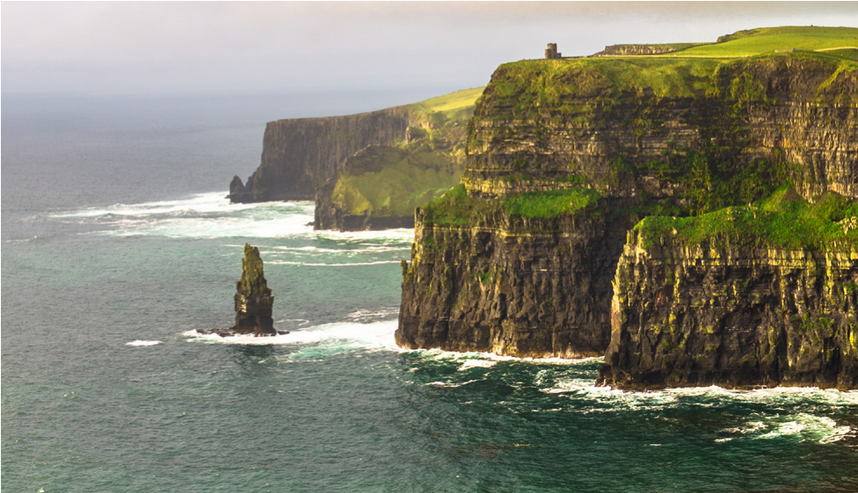
Return application to:

Members Wanted
Ladies Ancient Order of Hibernians, Inc.
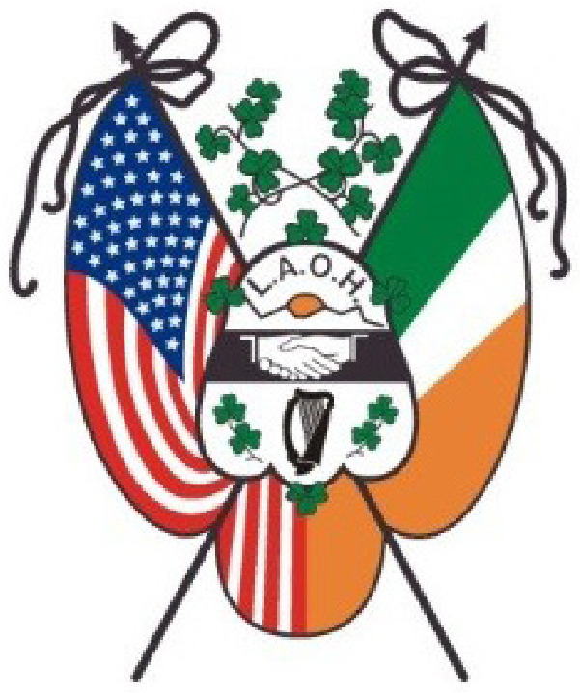
Over 125 years strong
Seeking Women
18 years or older Roman Catholic
Irish by birth, descent, or adoption
Catholic wife or mother of a member of the Ancient Order of Hibernians in America, Inc. (AOH) Apply today! ladiesaoh.com/membership

Friendship - Unity - Christian Charity

The purpose of the Ladies Ancient Order of Hibernians, Inc is to:
- Promote Friendship, Unity and Christian Charity.
- Foster and sustain loyalty to the Roman Catholic Church and the United States of America among its members.
- Aid and advance, by all legitimate means, the aspirations and endeavors of the Irish people to achieve complete and absolute independence.
- Foster the ideals, perpetuate the history and traditions, and promote the culture of the Irish people.
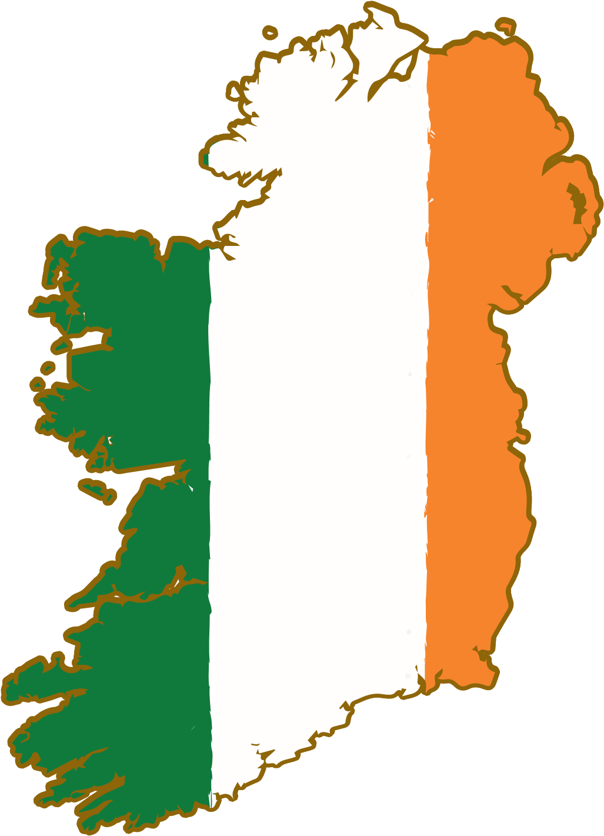
Connect to your Irish heritage
Sponsor an Irish History Contest, Irish American Award at National History Day,
and promote March as Irish American Heritage Month.

Build and foster friendships
Divisions in 30 States from coast to coast fostering a sisterhood of friendship with Irish American Catholic Women.

Give back to your community
Members share their time, talent and treasure to support local projects and organizations,
specifically Church supported organizations and other Charities. Assistance and support
are provided directly to all in need, especially the hungry, homeless, women and children.

National Activities
- Maintain a special relationship with the University of Notre Dame. Since 1978, the LAOH, in partnership with the AOH, has sponsored a Hibernian
Scholarship, Lectures and Research
Grants.
- Sponsor of the Lillian Fay Scholarship at Trinity College in Washington D.C.
- Support of The Missionary Society of St. Columban. Since 1935, thousands of dollars have been collected and donated to help the Columban Fathers and Sisters in their ministries around the world.
- Support Project St. Patrick since 1996. A joint project with the AOH that offers financial grants to Seminarians and those in Religious formation.
- Provide monetary support through
donations to Support Our Aging Religious (SOAR).
- Support Freedom for All Ireland (FFAI). A joint project with the AOH that provides assistance to cross community groups in the North of Ireland with community projects and justice initiatives to reinforce the peace that was brought to the North of Ireland with the Good Friday Agreement.

